Nama : Fadli Muhammad Arsyi

Nim : 6701223153

Kelas : D3SI-46-01

Assessment 1 PABW

Commit v1.0

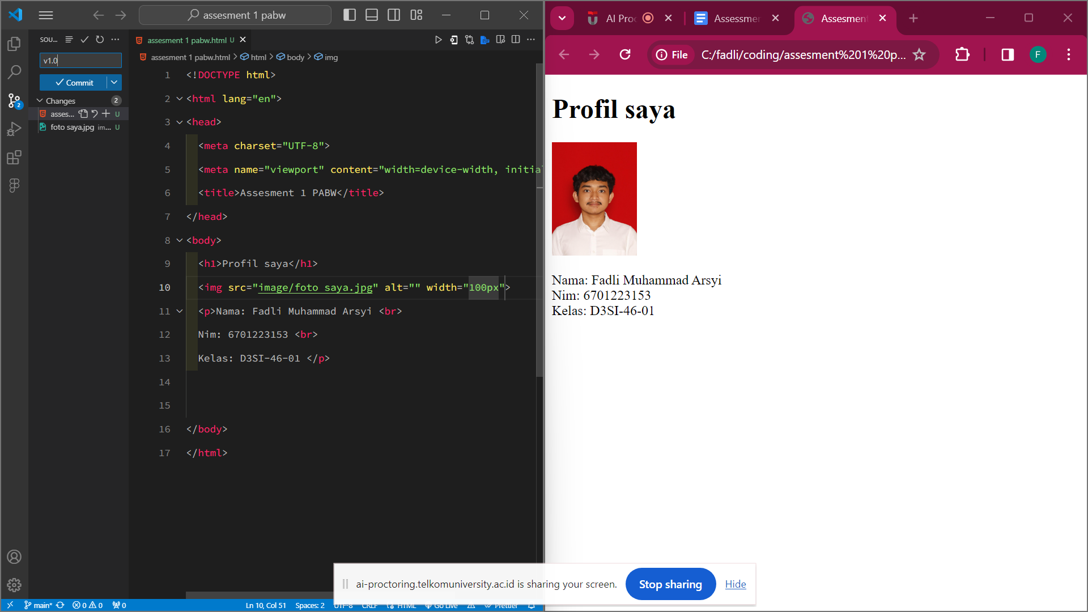

V1.1

V1.2

V1.3

V1.4

V1.5

V1.6

V1.7

